AIRLESS TYRES

Vincent Linish D’Souza
4NM06ME411
VIIth SEM mech
NMAMIT, Nitte

ABSTRACT

Anyone who has ever driven a car run on a flat tire, but what if your tires could never go flat? In recent years a number of companies and inventors have been working on creating airless tires that would be impossible to puncture. Non-pneumatic tires (NPT), or Airless tires, are tires that are not supported by air pressure. They are used on some small vehicles such as riding lawn mowers and motorized golf carts. They are also used on heavy equipment such as backhoes, which are required to operate on sites such as building demolition, where tire puncture is likely. Tires composed of closed-cell polyurethane foam are also made for bicycles and wheelchairs. The main advantage of airless tires is that they cannot go flat, but they are far less common than air-filled tires.
The most well known design in this field is the Michelin Tweel, a combination wheel and tire. The design was one of the first to emerge, bringing the idea of non-pneumatic tires to the public's attention. But Michelin has been slow to roll out the technology beyond the test phase.in light of this; a company called resilient technologies has also been working on an airless tire. The company recently announced that prototypes of their honeycomb-like tires will ship in 2011 for use in the US military. This will no doubt help the airless tire field, as will other startup companies working on the task like Britek.

TABLE OF CONTENTS

- PNEUMATIC TIRE
- AIRLESS TIRES
- CONSTRUCTION
- WORKING
- BENEFITS
- THE FUTURE OF AIRLESS TIRES
- REFERENCES

PNEUMATIC TIRE

A pneumatic, or air-filled, tire is made of an airtight inner core filled with pressurized air. A tread, usually reinforced with steel belting or other materials, covers this inner core and provides the contact area with the road. The pressure of the air inside the tire is greater than atmospheric air pressure, so the tire remains inflated even with the weight of a vehicle resting on it. The tire’s air pressure provides resistance against forces that try to deform the tire, but it gives to a certain degree -a cushioning effect as the tire hits bumps in the road. If you’ve ever taken a ride in an old-fashioned carriage with wooden wheels, you know what a difference a pneumatic tire makes.

Pneumatic tires do have drawbacks, especially in high-performance or highly dangerous applications. The main problem, of course, is that a puncture of the tire results in total failure. A blowout at high speeds can lead to a dangerous car accident. Military planners are concerned with tires getting blown out by gunfire or explosion shrapnel. A vehicle crew’s worst nightmare is getting trapped in a fire zone because their tires are all flat. Obviously, an airless tire can't be disabled by a single puncture

The earliest tires were bands of iron placed on wooden wheels, used on carts and wagons. The tire would be heated in a forge fire, placed over the wheel and quenched, causing the metal to contract and fit tightly on the wheel. A skilled worker, known as a wheelwright, carried out this work. The outer ring served to "tie" the wheel segments together for use, providing also a wear-resistant surface to the perimeter of the wheel. So these tires were able to sustain very heavy pressures.

AIRLESS TIRES

Non-pneumatic tires (NPT), or Airless tires, are tires that are not supported by air pressure. Airless tires generally have higher rolling friction and provide much less suspension than similarly shaped and sized pneumatic tires. Other problems for airless tires include dissipating the heat buildup that occurs when they are driven. Airless tires are often filled with compressed polymers (plastic), rather than air.
The Tweel (a portmanteau of tire and wheel) is an experimental tire design developed by the French tire company Michelin. The tire uses no air, and therefore cannot burst or become flat. Michelin is currently developing an integrated tire and wheel combination, the "Tweel” that operates entirely without air. Automotive engineering group of mechanical engineering department at Clemson University is developing a low energy loss airless tire with Michelin through the NIST ATP project. The Tweel would be the most radical change in the tire industry since the radial tire was invented nearly 60 years ago. Other changes include no more deadly blowouts. And in time, no more used-tire mountains or the need for as many shredding and recycling stations. The Tweel is durable. Forget a nail, an armored vehicle with Tweel can go over an exploding landmine and keep moving. But for the car, the Tweel is still just a concept. On a test drive on tweels, a sedan handles well enough. The biggest problem is noise, once the speed hits about 50 mph. The noise gets worse the faster you go.
Resilient Technologies and Wisconsin-Madison's a company specializing in Polymer Engineering and design are creating a "non-pneumatic tire" (no air required) which is basically a round polymeric honeycomb wrapped with a thick, black tread and that will support the weight of add-on armor, survive an IED attack, and the tires are expected to maintain a speed of 75 mph for 60 miles with 10% damage to the honey comb structure. Honeycomb structure is designed to support the load placed on the tire, dissipate heat and offset some of these issues. The patent-pending design mimics the precise, six-sided cell pattern found in a honeycomb and best duplicates the "ride feel" of pneumatic tires, according to the developers. The goal was to reduce the variation in the stiffness of the tire, to make it transmit loads uniformly and become more homogenous, and the best design, as nature gives it to us, is really the honeycomb.

CONSTRUCTION

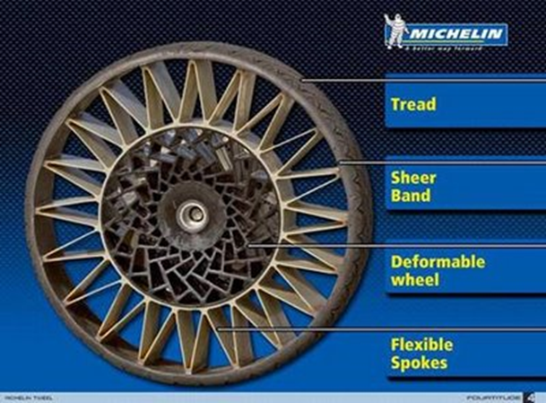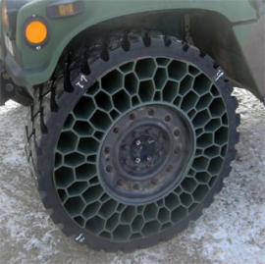
- (b)
Fig: (a) TWEEL
(b) NPT

The Tweel consists of a cable-reinforced band of conventional tire rubber with molded tread, a shear band just below the tread that creates a compliant contact patch, and a series of energy-absorbing polyurethane spokes. The rectangular spokes can be designed to have a range of stiffness’s, so engineers can control how the Tweel handles loads. The inner hub contains a matrix of deformable plastic structures that flex under load and return to their original shape. By varying the thickness and size of the spokes, Michelin can generate a wide array of ride and handling qualities. The tread can be as specialized as any of today's tires and is replaceable when worn.
Resilient Technologies engineers work on different combinations of materials to make the honeycomb design. That includes various cocktails of rubber, chemicals and polymer plastics that are put through their paces in equipment that pushes, pulls, prods, overheats and freezes them. The tire consists of a round polymeric honeycomb wrapped with a thick, black tread. The goal was to reduce the variation in the stiffness of the tire, to make it transmit loads uniformly and become more homogenous, and the best design, as nature gives it to us, is really the honeycomb. This particular geometry also does a great job of reducing noise and heat levels while rolling-two common problems with past models.

WORKING

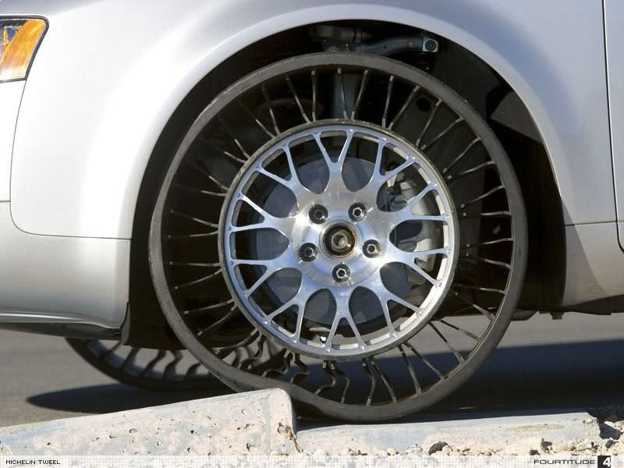

When the Tweel is put to the road, the spokes absorb road impacts the same way air pressure does in pneumatic tires. The Tweel's hub connects to flexible polyurethane spokes which are used to support an outer rim and assume the shock-absorbing role of a traditional tire's pneumatic properties. The tread and shear bands deform temporarily as the spokes bend, then quickly spring back into shape. Tweels can be made with different spoke tensions, allowing for different handling characteristics. More pliant spokes result in a more comfortable ride with improved handling. The lateral stiffness of the Tweel is also adjustable. However, you can’t adjust a Tweel once it has been manufactured. You’ll have to select a different Tweel. For testing, Michelin equipped an Audi A4 with Tweels made with five times as much lateral stiffness as a pneumatic tire, resulting in very responsive handling.
Michelin reports that the Tweel prototype is within five percent of the rolling resistance and mass levels of current pneumatic tires. That translates to mean within one percent of the fuel economy of the tires on your own car. Since the Tweel is very early in its development, Michelin could be expected to improve those numbers.

BENEFITS

No more air valves. No more air compressors at Petrol Pumps. No more flat tires in the middle of long drives. The Tweel promises performance levels beyond those possible with conventional pneumatic technology. Potential benefits of the Tweel include the obvious safety and convenience of never having flat tires. Also, the concept has the potential for true performance gains. Eventually, it may be able to outperform conventional tires since it can be designed to have high lateral strength (for better handling) without a loss in comfort since the design of the spokes allows the vertical and lateral stiffness to be tuned independently. The tread patterns may incorporate holes in the design thus eliminating or significantly reducing aquaplaning. Because only the tread around the circumference would be disposed of when worn as opposed to a whole tire, the environmental impact should be less. The Tweel can also withstand a police 'stinger' spike strip, which would force law enforcement to adapt in order to catch a suspect in a vehicle equipped with Tweels.

THE FUTURE OF AIRLESS TIRES

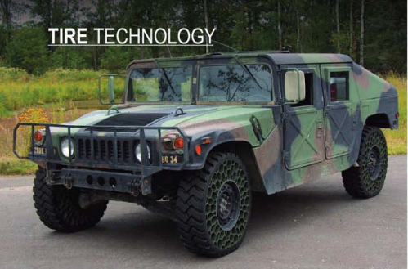
The first large-scale applications may be in the military where a flat-proof tire would be advantageous. Military testing has indicated that the Tweel deflects mine blasts away from the vehicle better than standard tires and that the Tweel remains mobile even with some of the spokes are damaged or missing. NASA has contracted Michelin to develop a wheel for the next generation Lunar Rover based on the Tweel.[3] This has resulted in the Lunar Rover Initiative AB Scarab wheels. The Tweel does have several flaws (aside from the name). The worst is vibration. Above 50 mph, the Tweel vibrates considerably. That in it might not be a problem, but it causes two other things: noise and heat. A fast moving Tweel is unpleasantly loud. Long-distance driving at high speeds generates more heat. Another problem involves the tire industry. Making Tweel is quite a different process than making a pneumatic tire. The sheer scale of the changes that would need to be made to numerous factories, not to mention tire balancing and mounting equipment in thousands of auto repair shops, presents a significant (though not insurmountable) obstacle to the broad adoption of airless tires.
Given the high speed problems with the Tweel, the first commercial applications will be in lower-speed, lower-weight vehicles such as wheelchairs, scooters, and other such devices. Michelin also has additional projects for Tweel on small construction equipment, such as skid steer loaders, for which it seems well-suited. They are initially working on Tweel use in low-speed applications, such as on construction vehicles. The Tweel is perfect for such use because the high-speed vibration problems won’t come into play, and the ruggedness of the airless design will be a major advantage on a construction site The Tweel is durable. Forget a nail, an armored vehicle with Tweels can go over an exploding landmine and keep moving. But for the car, the Tweel is still just a concept. On a test drive on Tweels, a sedan handles well enough. Some construction vehicles use them on sites with debris that can easily shred a pneumatic tire, but solid tires give an incredibly rough ride, generate a lot of heat, and might be even worse if a piece came off during an explosion, because it could not easily be repaired. The NPT’s honeycomb structure is designed to support the load placed on the tire, dissipate heat and offset some of these issues.

REFERENCES

Journal: Diesel Progress North American Edition December 2008
http://onemansblog.com/2007/08/31/michelin-tweel-the-airless-tire/
www.resilienttech.com/honeycomb-airless-tire-designed-by-nature
http://en.wikipedia.org/wiki/Airless_tire
http://auto.howstuffworks.com/tweel-airless-tire.htm

