SOLAR COLLECTORS
Solar Collector:
A solar thermal collector is a solar collector designed to collect heat by absorbing sunlight. The term is applied to solar hot water panels, but may also be used to denote more complex installations such as solar parabolic, solar trough and solar towers or simpler installations such as solar air heat. The more complex collectors are generally used in solar power plants where solar heat is used to generate electricity by heating water to produce steam which drives a turbine connected to an electrical generator. The simpler collectors are typically used for supplemental space heating in residential and commercial buildings. A collector is a device for converting the energy in solar radiation into a more usable or storable form. The energy in sunlight is in the form of electromagnetic radiation from the infrared to the ultraviolet wavelengths. The solar energy striking the Earth's surface depends on weather conditions, as well as location and orientation of the surface, but overall, it averages about 1kW/m2under clear skies with the surface directly perpendicular to the sun's rays.

Types of Solar Collectors:
There are basically two types of solar collectors:
- Non-concentrating
- Concentrating
In the non-concentrating type, the collector area (i.e. the area that intercepts the solar radiation) is the same as the absorber area (i.e., the area absorbing the radiation). In these types the whole solar panel absorbs the light.
Concentrating solar collector usually has concave reflecting surfaces to intercept and focus the sun’s beam radiation to a smaller receiving area, thereby increasing the radiation flux. This reduces heat losses and increases efficiency at high temperatures. Another advantage is that reflectors can cost substantially less per unit area than collectors. This class of collector is used for high-temperature applications such as steam production for the generation of electricity. These collectors are best suited to climates that have an abundance of clear sky days.

Types of Non-concentrating Solar Collector:
Non-concentrating solar collectors can be classified as:
- Flat Plate Solar Collectors
- Evacuated Tube Solar Collector

Flat Plate Solar Collector:
In flat-plate collectors there is no optical concentration of sunlight and they are generally stationary . In addition to this their outlet temperature capability is below 100 °C. Temperature close to the boiling point of water can be achieved using flat plate solar collector. However to reach higher temperatures evacuated-tube collectors and focusing collectors are used. In evacuated-tube collectors they use vacuum to reduce heat lost and to protect the absorber coating from deteration.By this way they can reach temperatures up to 140 °C and they can collect both direct and diffuse solar radiation. A flat plate collector is basically a black surface that is placed at a convenient path of the sun. And a typical flat plate collector is a metal box with a glass or plastic cover (called glazing) on top and a dark-colored absorber plate on the bottom. The sides and bottom of the collector are usually insulated to minimize heat loss.[11] The main components of flat plate solar collector are:
- Absorber Plate
- Flow Passage
- Cover Plate
- Insulation
- Enclosure
Absorber Plate:
It is usually made of copper, steel or plastic. The surface is covered with a flat black material of high absorptance. If copper or steel is used it is possible to apply a selective coating that maximizes the absorptance of solar energy and minimizes the radiation emitted by plate.
Flow Passage:
The flow passages conduct the working fluid through the collector. If the working fluid is a liquid, the flow passage is usually a tube that is attached to or is a part of absorber plate. If the working fluid is air, the flow passage should be below the absorber plate to minimize heat losses.
Cover Plate:
To reduce convective and radiative heat losses from the absorber, one or two transparent covers are generally placed above the absorber plate. They are usually be made from glass or plastic.
Insulation:
These are some materials such as fiberglass and they are placed at the back and sides of the collector to reduce heat losses.
Enclosure:
A box that the collector is enclosed in holds the components together, protect them from weather, facilitates installation of the collector on a roof or appropriate frame [12].
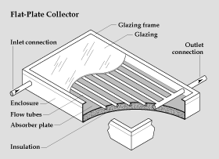
Figure 3.1: Flat Plate Solar Collector (Source: US Energy Department)
Properties of materials for a flat Plate Solar Collector:
Absorber Plate and Flow Passage:
Copper, which has high conductivity and is corrosion-resistant, is the material for absorber plates, but because copper is expensive, steel is also widely used. For a copper plate 0.05 cm thick with 2 cm tubes spaced 20 cm apart in good thermal contact with the copper. The surface of the absorber plate determines how much of the incident solar radiation is absorbed and how much is emitted at a given temperature. Flat black paint which is widely used as a coating has an absorptance of about 95 percent for incident shortwave solar radiation. It is durable and easy to apply [13].
Table 3.1: Characteristics of materials for absorber plate [12]
Material | Absorptance (𝜶𝒑) | Emittance (𝜺) | Break Down Temperature (°C) | Comments
Black Silicon Paint | 0.86 - 0.94 | 0.83 – 0.89 | 350 | Silicon Binder
Black Copper over Copper | 0.85 - 0.9 | 0.08 – 0.12 | 450 | Patinates with Moisture
Black Chrome Over Nickel | 0.92 – 0.94 | 0.07 – 0.12 | 450 | Stable at High Temperatures
Cover Plate:
A cover plate for a collector should have a high transmittance for solar radiation and should not detoriate with time. The material most commonly used is glass. A 0.32 cm thick sheet of window glass ( iron content, 0.12 percent ) transmits 85 percent of solar energy at normal incidence. And all glass is practically opaque to long-wavelength radiation emitted by the absorber plate.
Some plastic materials can be used for collector glazing. They are cheaper and lighter than glass and, because they can be used in very thin sheets, they often have higher transmittance. However, they are not as durable as glass and they often degrade with exposure to ultraviolet radiation or high temperatures [12].
Table 3.2: Characteristics of material for cover plate [12].
Test | Polyvinyl Fluoride | Polyester | Polycarbonate | Fiber glass reinforced
Solar Transmission, % | 92 - 94 | 85 | 82 - 89 | 77 - 90
Maximum Operating Temp (°C) | 110 | 100 | 120-135 | 90
Length of Life in Years | 5 | 4 | ---- | 7 - 20
Thickness (mm) | 1 | 0.025 | 3.2 | 1

Enclosure and Insulation:
The collector enclosure is usually made from steel, aluminum or fiber glass. And order to prevent heat from escaping through the back of the collector, a layer of insulation is placed behind the absorber plate.

Table 3.3: Characteristics of material for insulation [12]

Material | Density (𝒌𝒈𝒎𝟑 ) | Thermal Conductivity at 100(°C) (𝑾𝒎 ) | Temperature Limits (°C)
Fiber Glass with Organic Binder | 11 | 0.059 | 175
--do-- | 16 | 0.050 | 175
--do-- | 24 | 0.045 | 175
--do-- | 48 | 0.043 | 175

Orientation of Flat Plate Solar Collector:
Flat plate collectors are divided in three main groups according to how they are oriented:

- Flat plate collectors facing south at fixed tilt
- One-axis tracking flat-plate collectors with axis oriented north-south
- Two-axis tracking flat-plate collectors

Flat Plate Collector Facing South at Fixed Tilt:
To optimize performance in the winter, the collector can be tilted 15 ° greater than the latitude; to optimize performance in the summer, the collector can be tilted 15 ° less than the latitude [14].
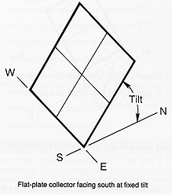
Figure 3.2: Flat Plate Collector at Fixed Tilt [14]
One Axis Tracking Flat Plate Collector with Axis Oriented North-South:
These trackers pivot on their single axis to track the sun, facing east in the morning and west in the afternoon as shown in figure 3.3.

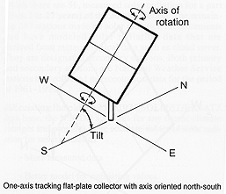
Figure 3.3: Flat-plate collector one axis tracking [14].

Two Axis Tracking Flat Plate Collector:
Tracking the sun in both azimuth and elevation, these collectors keep the sun's rays normal to the collector surface as shown in figure 3.4.

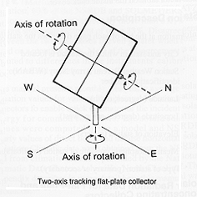
Figure 3.4: Two Axis Tracking Flat Plate Collector [14]
Governing Equations for Flat Plate Solar Collector:
In the solar-energy industry great emphasis has been placed on the development of "active" solar energy systems which involve the integration of several subsystems: solar energy collectors, heat-storage containers, heat exchangers, fluid transport and distribution systems, and control systems. The major component unique to active systems is the solar collector. This device absorbs the incoming solar radiation, converting it into heat at the absorbing surface, and transfers this heat to a fluid (usually air or water) flowing through the collector. The warmed fluid carries the heat either directly to the hot water or space conditioning equipment or to a storage subsystem from which can be drawn for use at night and on cloudy days. A precise and detailed analysis of a solar flat plate collector is quite complicated because of the many factors involved. Efforts have been made to combine a number of the most important factors into a single equation and thus formulate a mathematical model which will describe the thermal performance of the collector in a computationally efficient manner.

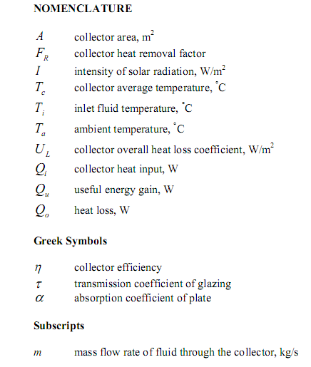

Flat-plate collectors
Flat-plate collectors are the most common solar collector for solar water-heating systems in homes and solar space heating. A typical flat-plate collector is an insulated metal box with a glass or plastic cover (called the glazing) and a dark-colored absorber plate. These collectors heat liquid or air at temperatures less than 80°C.
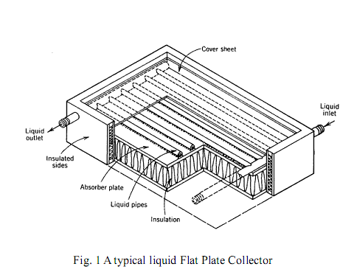
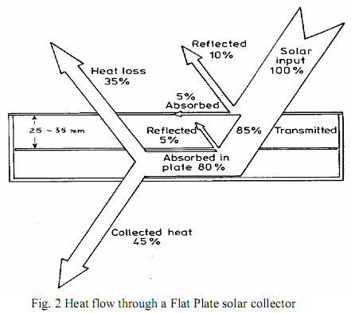
Flat-plate collectors are used for residential water heating and hydronic space-heating installations.

Figure 2 shows a schematic drawing of the heat flow through a collector. The question is, how to measure its thermal performance, i.e. the useful energy gain or the collector efficiency. Thus it is necessary to define step by step the singular heat flow equations in order to find the governing equations of the collector system.
Figure 3 shows the schematic of a typical solar system employing a flat plate solar collector and a storage tank.
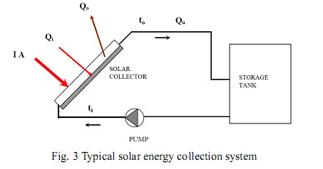
If I is the intensity of solar radiation, in W/m2, incident on the aperture plane of the solar collector having a collector surface area of A, m2, then the amount of solar radiation received by the collector is:
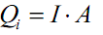
However, as it is shown Figure 2, a part of this radiation is reflected back to the sky, another component is absorbed by the glazing and the rest is transmitted through the glazing and reaches the absorber plate as short wave radiation. Therefore the conversion factor indicates the percentage of the solar rays penetrating the transparent cover of the collector (transmission) and the percentage being absorbed. Basically, it is the product of the rate of transmission of the cover and the absorption rate of the absorber. Thus,
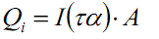
As the collector absorbs heat its temperature is getting higher than that of the surrounding and heat is lost to the atmosphere by convection and radiation. The rate of heat loss (Qo) depends on the collector overall heat transfer coefficient (UL) and the collector temperature
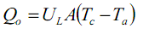
Thus, the rate of useful energy extracted by the collector (Q u), expressed as a rate of extraction under steady state conditions, is proportional to the rate of useful energy absorbed by the collector, less the amount lost by the collector to its surroundings.

It is also known that the rate of extraction of heat from the collector may be measured by means of the amount of heat carried away in the fluid passed through it, that is:
This is expressed as follows:

Equation 4 proves to be somewhat inconvenient because of the difficulty in defining the collector average temperature. It is convenient to define a quantity that relates the actual useful energy gain of a collector to the useful gain if the whole collector surface were at the fluid inlet temperature. This quantity is known as “the collector heat removal factor (FR)” and is expressed as:

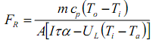

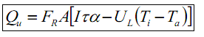
The maximum possible useful energy gain in a solar collector occurs when the whole collector is at the inlet fluid temperature. The actual useful energy gain (Qu), is found by multiplying the collector heat removal factor (FR) by the maximum possible useful energy gain. This allows the rewriting of equation (4):

Equation is a widely used relationship for measuring collector energy gain and is generally known as the “HottelWhillier-Bliss equation”.

A measure of a flat plate collector performance is the collector efficiency (η) defined as the ratio of the useful energy gain (Q u) to the incident solar energy over a particular time period:

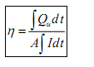
The instantaneous thermal efficiency of the collector is:

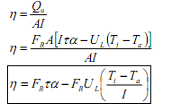

In a well-designed collector, the temperature difference between the plate and the fluid is small and the value of 𝜂 is nearly one. Typically 𝜂 = 0.85 and is almost independent of the operating conditions, and, since pipes and storage tanks should be well insulated, 𝑇𝑓≈𝑇𝑝 the collector plate temperature. The capture efficiency 𝜂𝑠𝑝 (and therefore also the collector efficiency 𝜂𝑐) would vary linearly with temperature. The performance of a flat plate collector, and in particular its efficiency at high temperatures, can be substantially improved by:
1. Reducing the convective transfer between the plate and the outer glass cover by inserting an extra glass cover

2. Reducing the radiative loss from the plate by making its surface not simply black but selective, i.e. strongly absorbing but weakly emitting

Evacuated Tube Solar Thermal Collectors:
The evacuated tube solar collector works by absorbing solar energy in the form of UV rays and converting it into thermal energy. An evacuated tube solar collector contains a number of evacuated tubes. Each evacuated tube is responsible for independently absorbing the sun's radiation that reaches it.
Evacuated tube heat pipe collectors can more easily attain the higher temperatures needed, they can collect and retain heat even when it is very cold outside, and due to their superior Incidence Angle Modifier they collect solar energy more evenly throughout the day resulting in a lower buffer or thermal storage requirement.
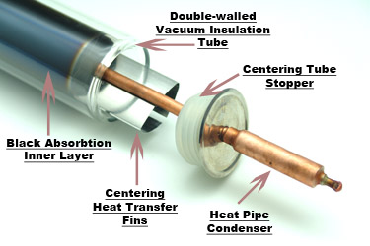
Evacuated Tubes
The tubes are made from low emissivity borosilicate glass (glass with a very low iron content that has superior durability and heat resistance ) with an all-glass seal and they employ AL/N on AL selective coating, which enables the use of the whole solar energy spectrum to generate heat; this produces greater thermal efficiency in bright sunshine but also produces high efficiency in overcast or diffuse sunlight conditions. Further, the tubes are evacuated and have a barium getter (vacuum indicator) which changes color from silver to white if a tube’s vacuum has been compromised.
An examination of the tubes shows that the outside is actually 2 layers of glass and a vacuum has been created between them. A good way to demonstrate this would be to fill an empty tube with very hot water and notice that it does not even get warm as you hold the tube in your hands. That is because of the “thermos effect” created by having a vacuum between the layers of glass.

Copper Header
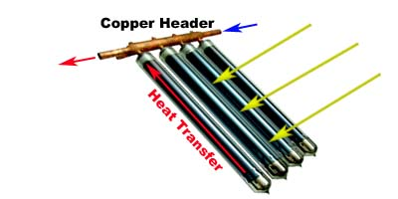
The header is made from copper which makes for excellent heat transfer and is corrosion resistant and allows all connections to be brazed rather than soldered. It uses “dry” plug-in heat pipes meaning that the connections are plug-and-play which makes installation or replacement very simple. By comparison, other evacuated tube systems that require the manifold be opened for installation or replacement which is time consuming and can cause burns to the installers hands on a sunny day.
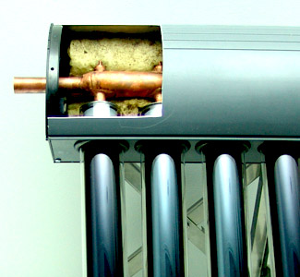
Aluminum Manifold

The manifold uses a powder-coated all-aluminum casing for durability, structural integrity and light weight. The light weight is important for ease of installation and to reduce total roof loading in larger installations that can in some cases include up to 150 collectors. The manifold is packed with glass wool insulation and is sealed with special UV stabilized silicone rubber that can withstand temperatures of up to 482 degrees F.

Heat Pipes
Some evacuated tube systems are what is called a U-Tube, meaning that the glycol solution enters and exist each tube as opposed to flowing across a manifold. The SPP evacuated tube system uses what is called a heat pipe.
A heat pipe allows for rapid heat transfer. The heat pipe itself is a copper tube that maintains a vacuum and contains a small amount of liquid. The low pressure (vacuum) in the copper pipes means that the liquid boils at a low temperature (about 30oC / 86oF), turning to steam and rushing up to the heat of the heat pipe, carrying heat. It dumps the heat (to the glycol solution running through the header), condenses and runs back down to repeat the process.

Technical Data：
Item Specification | One Target (Operation Temp. around 100C） | Three Targets (Operation Temp. around 100C） | Titan  (operation Temp. 120C-180C)
Absorptance of Selective Coating (AM1.5) | α≥92.5% | α≥93.5% | α≥96.0%
Emission of Selective Coating(80℃±5℃) | εh≤7.5% | εh≤6.5% | εh≤4.0%
Stagnation Parameter | Y≥220㎡℃/kW | Y≥240㎡℃/kW | Y≥280㎡℃/kW
Solar Radiance Exposure | H≤3.3MJ/㎡ | H≤3.0MJ/㎡ | H≤3.0MJ/㎡
Average Heat Loss Coefficient | ULT≤0.75W/(㎡•℃) | ULT≤0.65W/(㎡•℃) | ULT≤0.50W/(㎡•℃)
Selective Coating Material | AL-N/AL | SS-AL-N/Cu | Ti
Application field | Hot water | Hot water | Solar Air conditioner desalination of sea water Industrial project
Vacuum Quality | P≤3×10-3Pa
Pressure-proof | 0.6MPa
Impact Resistance | Steel Ball Test: steel ball with diameter of 30mm fall on the evacuated tube vertically from 450mm height, the evacuated tube is not damaged.
Transmittance of GlassTube | τ≥0.89 (AM1.5ISO9806-1:1994)
Material of GlassTube | Borosilicate Glass 3.3
Knots of GlassTube | Knots(Ø≤1mm) ≤2 pieces in area of 10mm×10mm; Knots(Ø≤2.5mm) ≤ 5 pieces in the whole tube

Item | Data（mm）
Diameter of Outer/Inner Tube | Φ47/37 | Φ58/47 | Φ70/58
Length of Tube | 1500;1600;1800;1920 | 1800;1920;2000;2100 | 150;1800;2100
Thickness of Tube | 1.60±0.15 2.0±0.15 2.2±0.15
Item | Data（mm）
Diameter of Outer/Inner Tube | Φ47/37 | Φ58/47 | Φ70/58
Length of Tube | 1500;1600;1800;1920 | 1800;1920;2000;2100 | 150;1800;2100
Thickness of Tube | 1.60±0.15 | 2.0±0.15 | 2.2±0.15

Comparisons:
Evacuated Tube Collector | Flat Plate Collector
Quick heat generation | Slow heat generation
Collector efficiency on higher temperature is high | Collector efficiency on higher temperature is low.
Heat loss in the tubes during the daytime is negligible (evacuated tubes) | Heat loss in the collector & tank during the day-time is high due to convection.
Convection and Convecting losses is low. | Convection and Convecting losses is high.
Emissivity is low. | Emissivity is high.
Satisfactory performance even in extreme cold condition (-18 deg. C) | Freezing of water will take place at high altitude causing damage to the collector.
Temperature range from 60deg. to 120 deg. | Temperature range from 60 deg. to 80 deg.
System hot water tank only is insulated using polyurethane insulation material which does not absorb water or moisture | Collector & tank insulated with glasswool/ rockwool, absorbs moisture & gets wet during monsoons reducing the efficiency of the system
Negligible scaling of tubes which can be cleaned manually (inner tube dia. Is 37mm). Loss of efficiency consequently is minimal | Heavy scaling of the copper/aluminum tubes which cannot be cleaned manually as the bore dia. is 12.50 mm. giving rise to substantial loss in efficiency of the system.
The collector glass tube absorbers being cylindrical the incident sun's rays on the tubes is at 90 degrees throughout the day. Hence peak heat absorption always. | The collector fins & tubes being flat the incident sun's rays will be at 90 degrees at noon only for peak absorption
In locations with average availability of solar energy over-sizing of the system glass tube collectors is not required. | Higher system sizing is required to get the desired result. Hence added cost.
Heat exchanger not required | Heat exchanger required
Advanced technology at competitive prices that is System Cost per unit water is low. | Old technology at higher prices
Hot water availability for 350 days in a year. | Hot water availability for 300 days in a year claimed.
System life above 15 years. | System life above 15 years
It is very easy to replace glass tube. | Difficult and expensive to replace glass sheet
Water quality is not effect the system. | Water quality effect the heating system forming scale over metal tube.
It has low maintenance | Its required high maintenance.
Grouting of Collectors not required. | Grouting of collectors are required.

